# MAHENDRA ENGINEERING COLLEGE

# NAMAKKAL

Signs with Smart Connectivity For Better Road Safety

**IBM NALAIYATHIRAN**

# Project Development – Delivery of sprint 2

**Creating Node-Red And Connect With Cloud And Web UI**

|  |  |
| --- | --- |
| **TITLE** | Signs with Smart Connectivity for  Better Road Safety |
| **DOMAIN NAME** | INTERNET OF THINGS |
| **TEAM ID** | PNT2022TMID17100 |
| **TEAM LEADERNAME** | SATHISHKUMAR V |
| **TEAM MEMBER NAME** | RANJITH R  PRAVEEN M  NAVEENRAJ V |
| **MENTOR NAME** | Dr. RAVIKUMAR |

CREATING NODE-RED SERVICE:

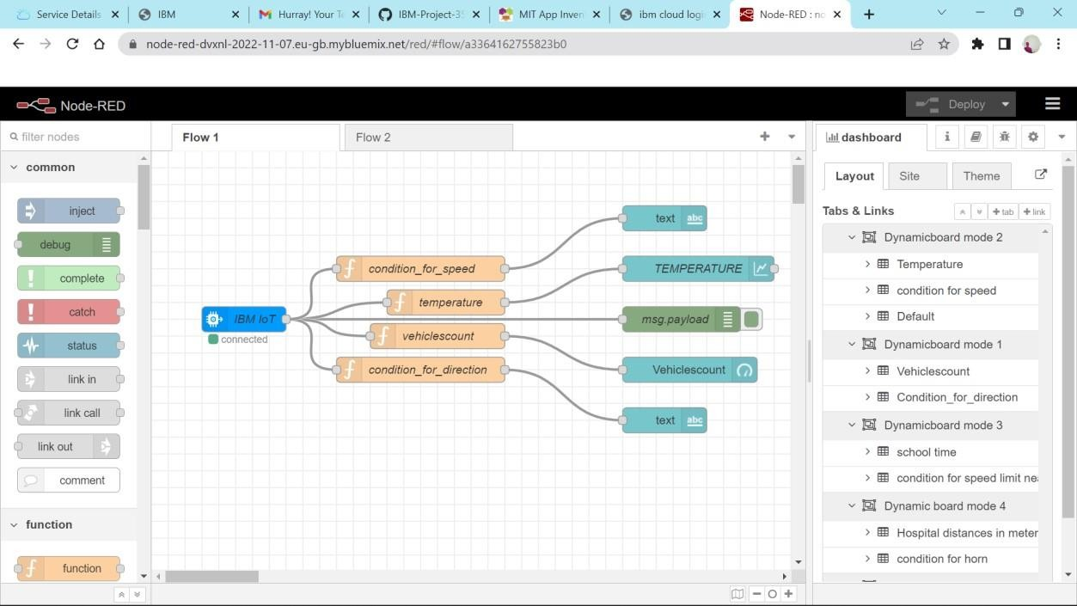

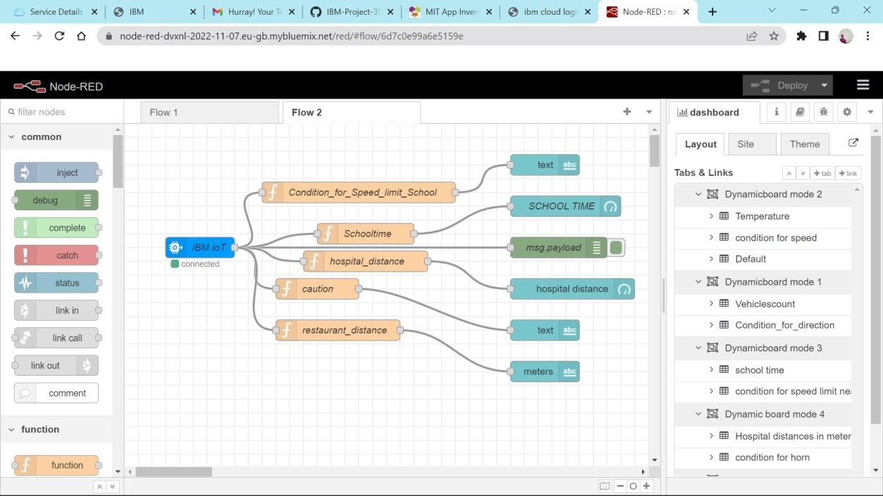

CONNECTING WITH IBM CLOUD: USING IBM IOT THROUGH API KEY:

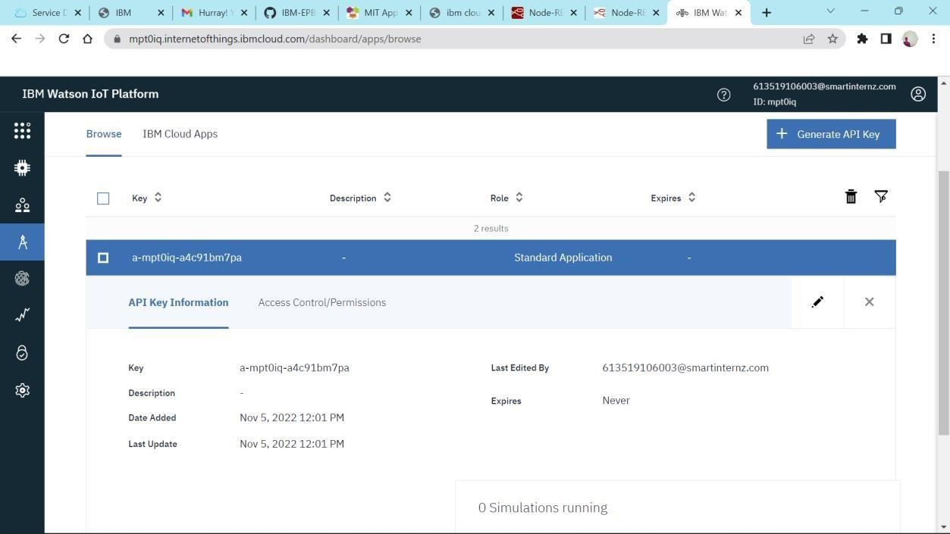

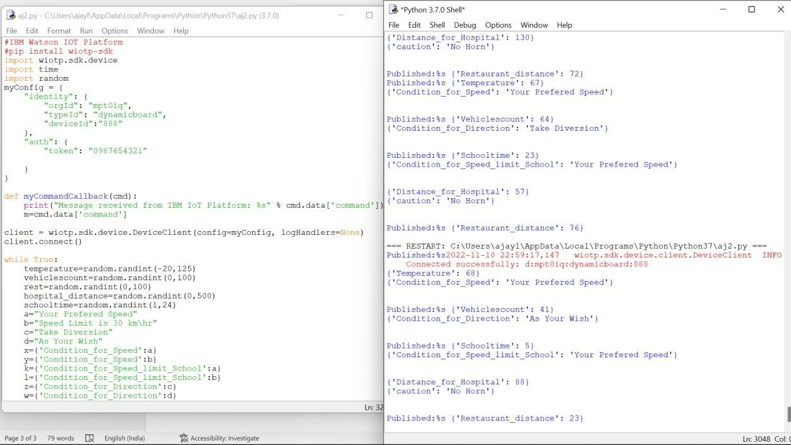TRANSFERING VALUES FROM PYTHON CODE:

NODE -RED DASHBOARD:

